FORTA Corporation
U.S.A. REPORT #50-02
Lost Circulation of LCM's in Combination with Calcium Carbonate
Acid Solubility
SUMMARY:
Calcium carbonate is often used in a drilling system when acid solubility is a desired characteristic. The following tests were performed on three different Lost Circulation Materials (LCM's) to determine their effectiveness and compatibility when used in conjunction with calcium carbonate. [Additional FORTA U.S.A. - Uniform Statistical Analysis - Research Reports are available on request.]

TEST METHOD:
A Particle Plugging Apparatus was used for testing of the bridging effectiveness of LCM's when used with calcium carbonate. Each LCM was evaluated at a single pressure of 1000 p.s.i., and held for a 10 minute period. The slot size to be Sealed was 3 mm x 30 mm. The lost fluid was measured for each material, noting the seal time if applicable.
TEST RESULTS:
The following graph shows the performance of each of the LCM products tested in terms of fluid loss after the 10 minute test period. Total fluid used in each test was 350 c.c., including 20 pounds per barrel of calcium carbonate.
LOST CIRCULATION SLOT SEALING TEST RESULTS
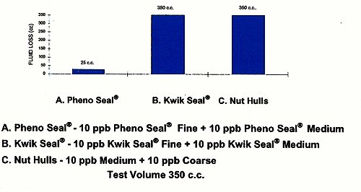
A. Pheno Seal® proved to be more effective than nut plug or fibers as a sealant when used in conjunction with calcium carbonate. Pheno Seal® showed a total fluid loss of only 25 c.c. at 10 minutes, and offered a seal time of 20 seconds at pressure.
B. Kwilk Seal® showed a total fluid loss (350 c.c.) at 1 1/2 minutes of pressure.
C. Nut hulls showed a total fluid loss (350 c.c.) at 1 1/2 minutes of pressure.
[From "Lost Circulation Testing: Calcium Carbonate Combined with Lost Circulation Materials," Montello, Inc., February 1996.]
TEST: ACID SOLUBILITY
Two LCM products were tested for acid solubility in a 15% concentration of hydrochloric acid.
A. Pheno Seal® - 13.505%
B. Kwik Seal® - 17.910%
[From "Acid Solubility of LCM Products, #M95-2325", Mud Tech Laboratories, March 1995.]
FORTA® Pheno Seal® is warranted to be free of defects and to meet all quality control standards set by the manufacturer. FORTA® has no control over the placement or use of the fluids in which Pheno Seal® is incorporated, therefore FORTA Corporation assumes no responsibility for the end product.
FORTA® and Pheno Seal® are registered trademarks of the FORTA Corporation.
Kwik Seal® is a registered trademark of Kelco Oil Field Group.

