FORTA Corporation
U.S.A. REPORT #50-01
Slot Sealing Comparison of LCM's
SUMMARY:
The prevention of significant fluid loss while drilling through fractured formations is of major concern. In the case of large pores or fractures, a bridging material is required to reduce the pores to a size that will enable a filter cake to be formed. For maximum effectiveness, the bridging material should be stable in the drilling fluid being used, be able to withstand high differential pressures, and be unaffected by temperature. The following tests were designed and performed to compare the bridging effectiveness of four different LCM materials at various pressures. [Additional FORTA U.S.A. - Uniform Statistical Analysis - Research Reports are available on request.]

TEST METHOD:
A Particle Plugging Apparatus (PPA) was modified with a special end cap to allow for testing the bridging effectiveness of lost circulation materials (LCM's) in a simulated fracture. A special disc, containing a 3 mm x 30 mm rectangular slot was used in place of the conventional aloxite discs to simulate a fracture. A 14.0 lb/gal weighted, dispersed fluid was lab formulated for the tests. The test fluid containing the LCM to be evaluated was poured into the test cell. The modified end cap was installed. The rest of the procedure was similar to running a standard PPA test. The LCM was evaluated at a single pressure setting for the full 10 minutes. This procedure was repeated for each pressure setting. The tests were performed at room temperature (80° F) at pressures of 500, 1000, 1500 and 2000 psi.
TEST RESULTS:
The following graphs show the performance of each of the four materials tested. The values reported represent the average of three test runs on each material at each pressure setting.
LOST CIRCULATION SLOT SEALING TEST RESULTS
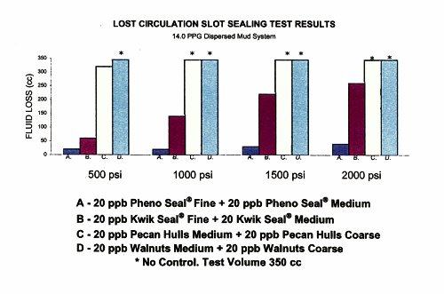
A. Pheno Seal®, a sized thermoset laminate, proved to be a durable, rapid-acting bridging agent. This allowed for the formation of an effective cake which prevented significant loss of whole mud. Due to the strength of Pheno Seal®, a bridge against the 500 psi through 2,000 psi test pressures was maintained for the full 10 minutes. The bridging and resulting seal were formed within the first minute of the test. Once the seal was formed, no additional mud was lost. At 2,000 psi, less than 15% of the test mud was lost before an effective bridge was established by the Pheno Seal® particles.
B. Kwik Seal®, a product containing a blend of fibrous and granular materials, became less effective as the test pressures increased. At 2,000 psi, approximately 75% of the test fluid was lost before the simulated fracture was sealed by the Kwik Seal®.
C., D. Two types of granular LCM products, pecan hulls and walnut hulls, did not provide effective bridging across the simulated fracture. The granular materials did not reduce the pore size enough that a mud cake could be formed. No effective seal was observed at the pressures tested.
[From. "Effective Remediation of Lost Circulation Slot Sealing Test Results", Montello, Inc., February 1996.]
FORTA® Pheno Seal® is warranted to be free of defects and to meet all quality control standards set by the manufacturer. FORTA® has no control over the placement or use of the fluids in which Pheno Seal® is incorporated, therefore FORTA Corporation assumes no responsibility for the end product.
FORTA® and Pheno Seal® are registered trademarks of the FORTA Corporation.
Kwik Seal® is a registered trademark of Kelco Oil Field Group.

